Experiment-7
Question: 1
Define a class with method to check prime or not
Code:
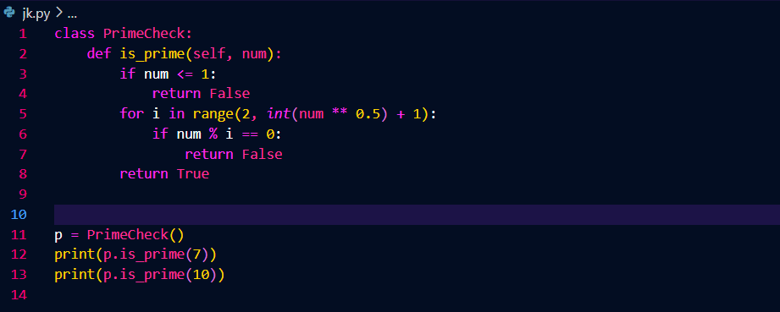
Output:
Question: 2
Define a class with method that returns biggest of three numbers
Code:
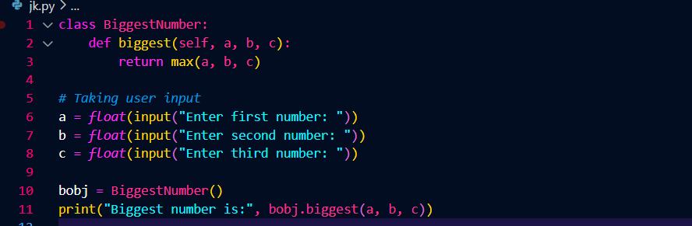
Output:


Question: 3
Define an employee class with method to find the total salary for the given basic salary
Code:
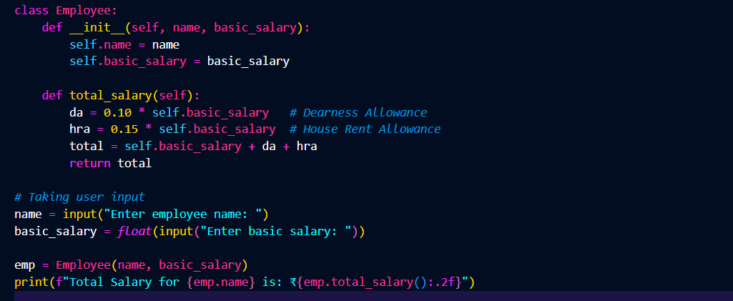
Output:


Question: 4
Define a class to store a list of employee objects and perform operations like adding, deletion and displaying with menu-driven approach
Code:
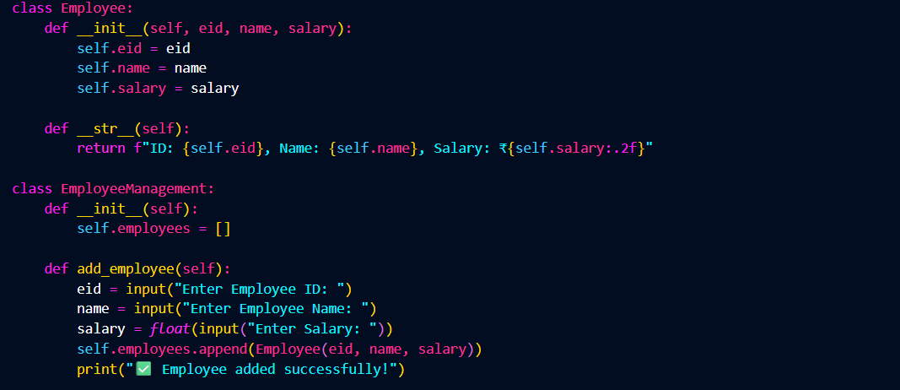
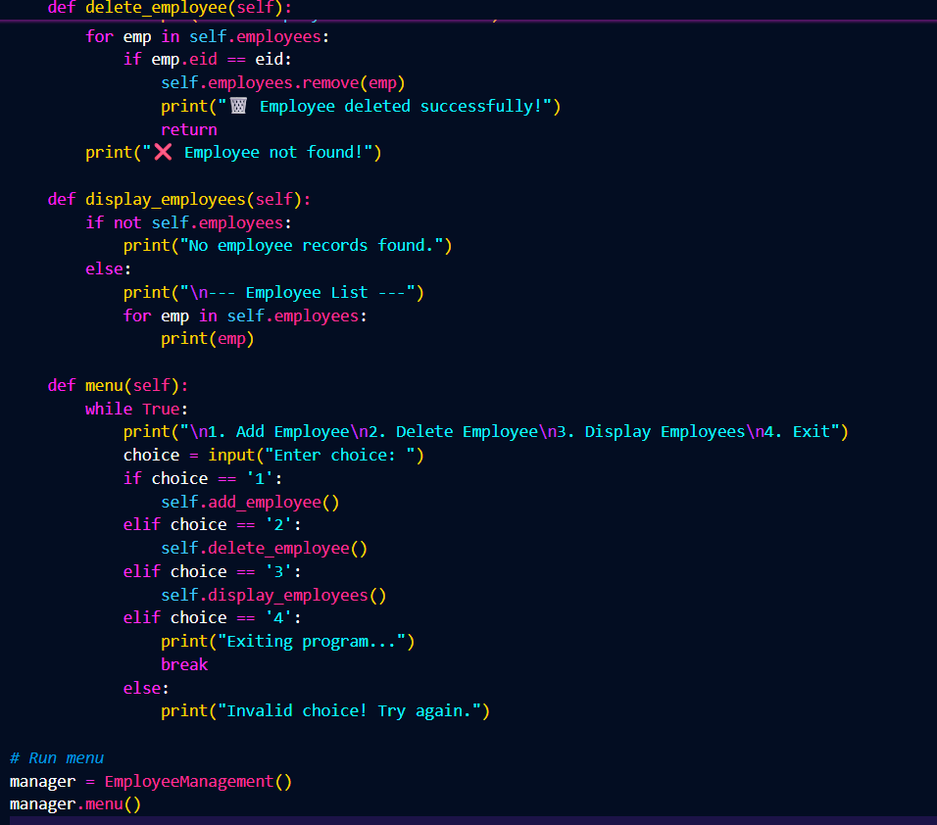
Output:

Question: 5
Define a class that stores information of order details of customers using dictionary

Code:
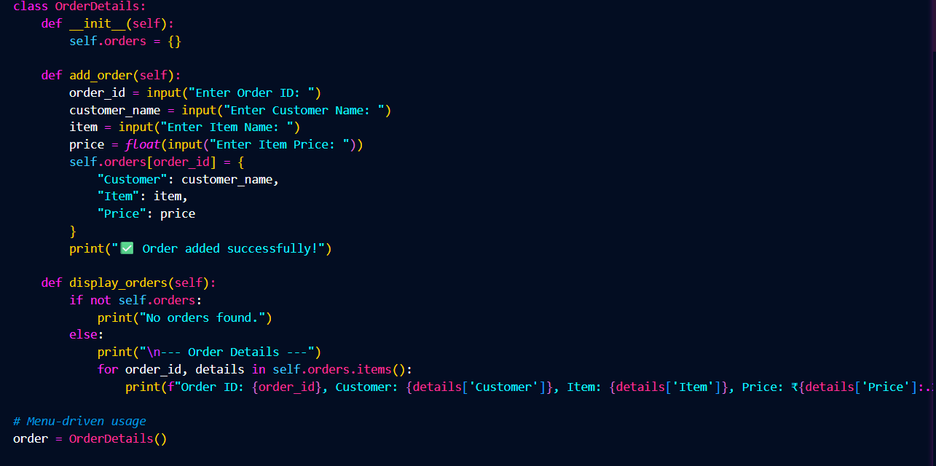
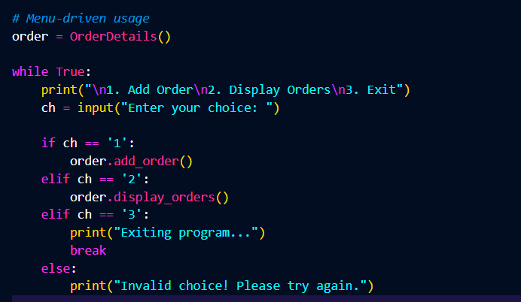
Output:


Submitted by:
Name= Abhinav Sharma
Reg no.= 2401020441
Branch= AI & DS

